
PROJECT CONCEPT NOTE
CARBON OFFSET UNIT (CoU) PROJECT
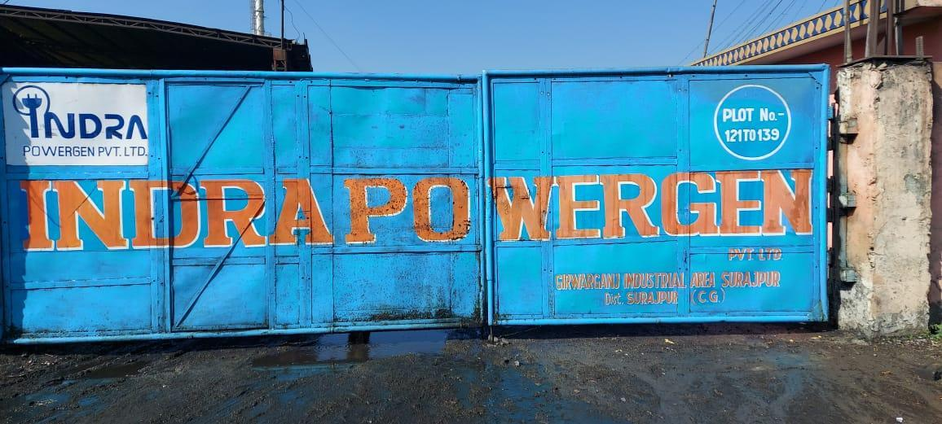

Title: 10 MW Biomass Power Project by Indra Powergen Pvt. Ltd.
Version 1.0
Date 02/02/2023
First CoU Issuance Period: 8 years, 00 months
Date: 01/01/2015 to 31/12/2022

Project Concept Note (PCN)
CARBON OFFSET UNIT (CoU) PROJECT
BASIC INFORMATION
Title of the project activity | 10 MW Biomass Power Project by Indra Powergen Private Limited
Scale of the project activity | Small Scale Project Activity
Completion date of the PCN | 02-02-2023
Project participants | M/S Indra Powergen Private Limited
Host Party | India
Applied methodologies and standardized baselines | AMS-I.D.: Grid connected renewable electricity generation --- Version 18
Sectoral scopes | 1-Energy industries (renewable - / non-renewable sources)
Estimated amount of total GHG emission reductions | 532,170 CoUs
Estimated amount of total GHG emission reductions per annum | 53,217 (tCO2eq per annum)

SECTION A. Description of project activity

A.1. Purpose and general description of Carbon offset Unit (CoU) project activity >>

The project 10 MW Biomass Power Project by Indra Powergen Private Limited
is located in Village – Narayanpur, Tehsil – Surajpur, District – Sarguja, State - Chhattisgarh, Country – India

The details of the registered project are as follows:

Purpose of the project activity:

The purpose of the project is essentially to utilize the available biomass fuels in the region effectively and generation of clean power. The project activity is a 10 MW biomass based power plant implementing at Narayanpur Village, Surajpur Tehsil, Sarguja District of Chhattisgarh. The electricity generated from the project activity will be exported to a grid system owned by the state owned power utility, Chhattisgarh State Electricity Board (CSEB). The project will also help to reduce ever increasing demand and supply
gap of electricity in the region.
The proposed project activity will generate power through sustainable means using rice husk without causing any negative impact on the environment and export the generated electricity to the 33/110 kV Baikunthpur sub- station owned by CSEB. The whole process supports climate change mitigation as it leads to emission reduction of 510,883 tonnes of CO2eq. over the crediting period of 10 years.
The Project was commissioned in 19/09/2009.
A.2 Do no harm or Impact test of the project activity>>
There are social, environmental, economic and technological benefits which contribute to sustainable development.

Social benefits:
- The proposed activity will generate employment for the local populace during various stages of its implementation. The project activity engages local populace during construction phase and for biomass collection, processing of biomass, transportation of biomass as well as in the operation of the power plant.
- Apart from the direct employment generation, the proposed project also encourages indirect employment by setting up other agro industries due to availability of power supply from the proposed project.
- Project activity will generate additional revenue to the formers and rice millers by the sale of crop residues and agro industrial waste.
- The proposed project will engage both genders in construction of the project, biomass collection; biomass processing etc during the operation lifetime of the project and this will lead to gender equity and prevent social disparities.

Environmental benefits:
- Biomass is a clean fuel and environmentally benign as compared to conventional fuels.
- The proposed project activity utilises biomass potential available for power generation, which otherwise is dominated by fossil fuels such as coal, lignite and gas. The project will not result in an increase of GHG emissions and cause no negative impact on the environment. The project generates real, measurable and long-term emissions reductions.
- The project utilizes surplus biomass residues and thereby reduces dependence on fossil fuels to certain
extent.
Economic benefits:
- The proposed project will bring in additional capital investment of Rs.392 millions to the region, which leads to development of the region.
- The project acts as a nucleus for other economic activities such as setting up of cottage industries, shops, hotels etc around the area contributing to the economic development around the project area.
- The proposed biomass plant will help local farmers in earning extra income by selling crop residues there by helping them to improve their economic standards.
- The proposed biomass based power generating plant facilitates the availability of continuous and
sustained power to the local industries and agricultural farmers located in remote areas, thereby avoiding the load shedding and low frequency of power.

A.3. Location of project activity >>
Country: INDIA.
District: Sarguja
Village: Narayanpur
Tehsil: Surajpur
State: Chhattisgarh
Code: 497229
Latitude - 23.211191 (23° 12' 40.2876'' N)
longitude - 82.923997 (82° 55' 26.3892'' E)
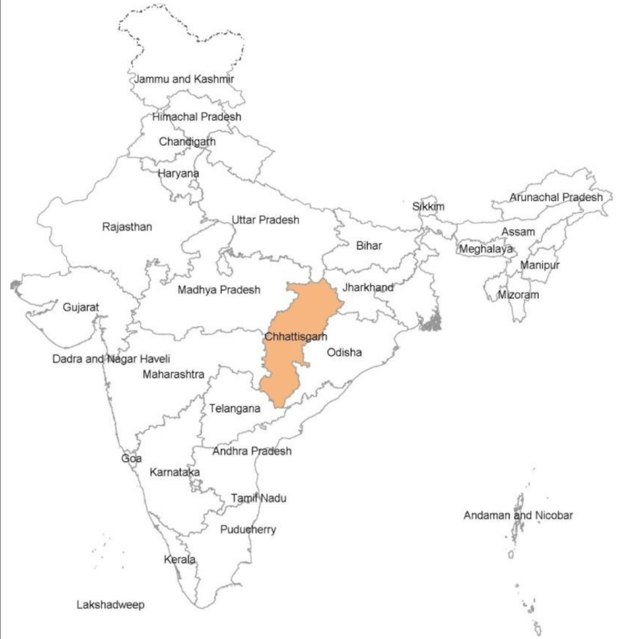

Map 1: Location of Chattisgarh state (yellow) in India Map 2: Location of Sarguja in Chhattisgarh State

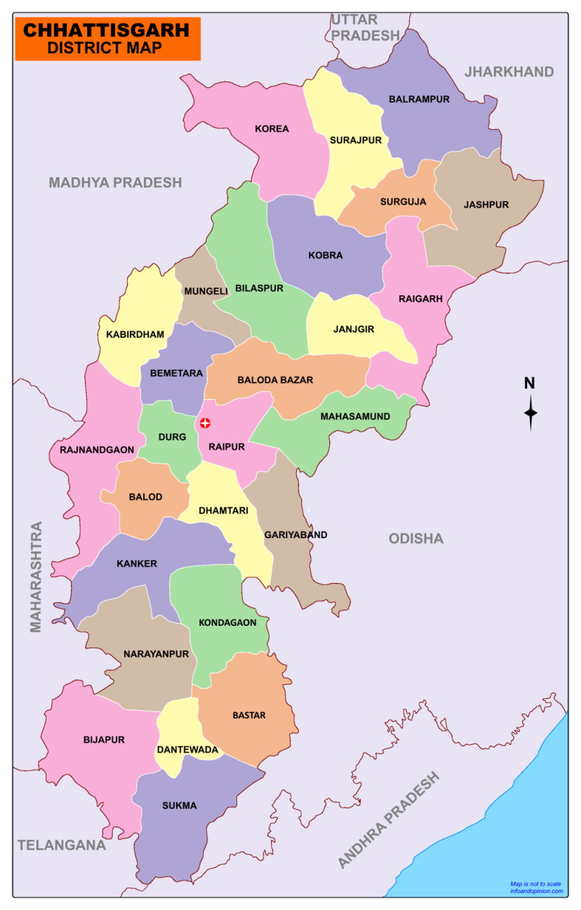
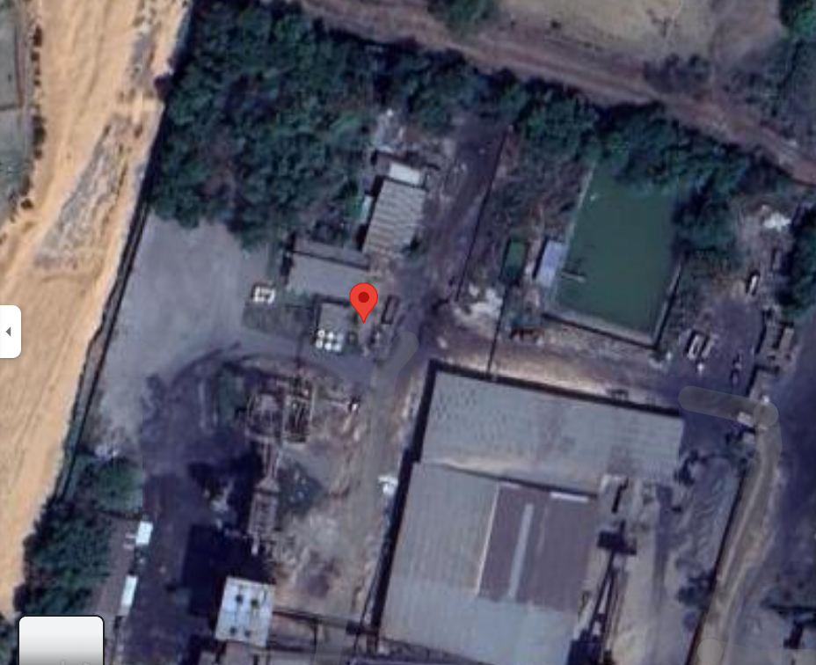

A.4. Technologies/measures >>

The capacity of the proposed CDM project is only 10 MW, which is well below the qualifying capacity of 15 MW, the project activity can be regarded as a small scale.
Technology

The basic technology is Rankine cycle route where direct combustion of biomass materials takes place through the multi-fuel fired boiler to generate high pressure and high temperature steam, which drives a reaction turbine generator set.

Equipments
The plant and machinery of the project consists of one number traveling grate boiler, one number steam turbine generator set, power evacuation system and fuel handling system etc. Other plant equipment includes HP heater, DM water system, water cooling system/radiator cooling system, compressed air system, fire fighting equipment, fuel and ash handling system, switchgear and switch yard etc. The technology of power generation through direct combustion of fuels is already established in India.

Power Generation
The capacity of the turbo generator is 10 MW, which generates electricity at 33/11 kV level for about 7920 hours in a year. It is anticipated that the plant can operate at 90 %. Annual estimate of power export to the grid system during first year is
Specification | Value
Boiler | Bi-drum, natural circulation  45 T/hr
Power evacuation | Grid Voltage - 33 KV
Energy production | Gross power – 10 MW  Net power for export -8.5 MW

A.5. Parties and project participants >>

Party (Host) | Participants
INDIA | M/S Indra Powergen Private Limited

A.6. Baseline Emissions>>

The baseline scenario identified at the PCN stage of the project activity is:
The baseline scenario identified at the PCN stage of the project activity is: Grid In the absence of the project activity, the equivalent amount of electricity would have been generated by the operation of fossil fuel-based grid-connected power plants and fed into Indian grid system, which is carbon intensive due to use of fossil fuels. Hence, baseline scenario of the project activity is the grid-based electricity system, which is also the pre-project scenario. Schematic diagram showing the baseline scenario:
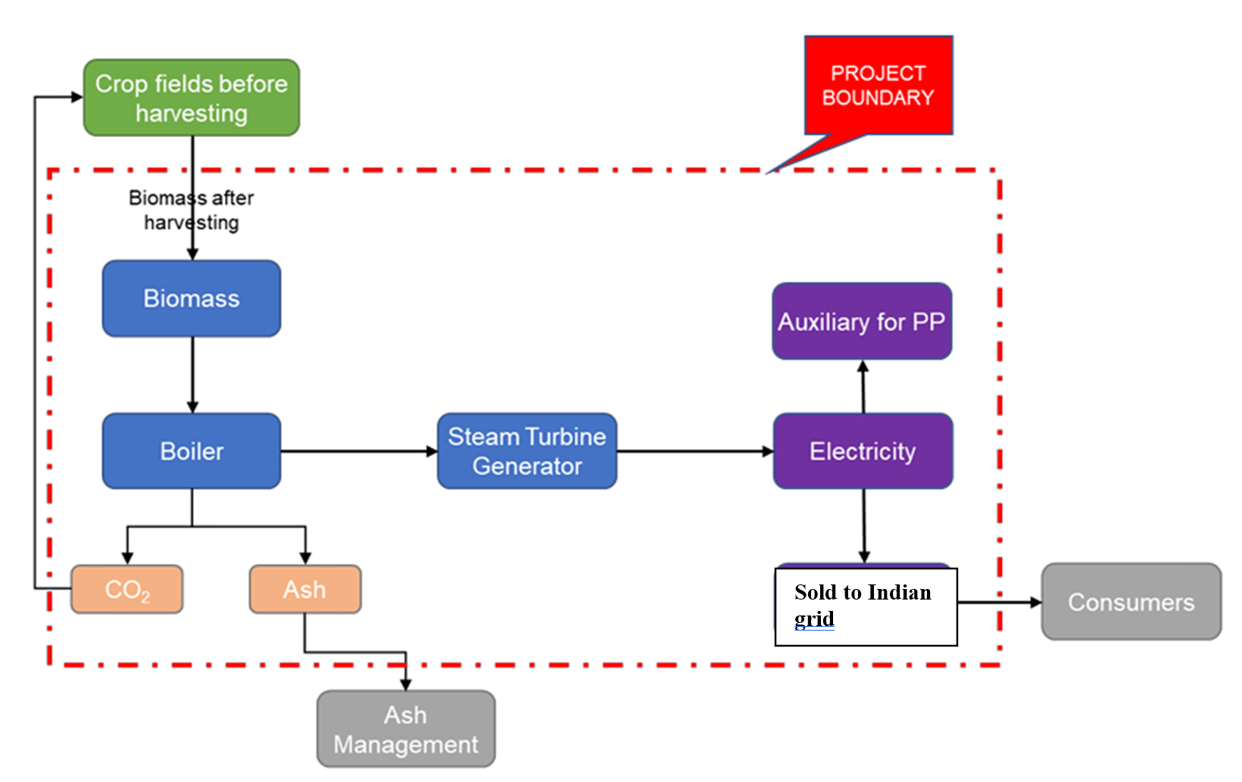
Baseline Scenario: As per the approved consolidated methodology AMS-I.D. Version 18, if the project activity is the installation of a new grid-connected renewable power plant/unit, the baseline scenario is the following: “The baseline scenario is that the electricity delivered to the grid by the project activity would have otherwise been generated by the operation of grid-connected power plants and by the addition of new generation sources into the grid”. The project activity involves setting up of a new power plant which generates electricity from combustion of biomass which is a renewable source and to supply the produced power to the grid. In the absence of the project activity, the equivalent amount of power would have been supplied by the Unified grid, which is fed mainly by fossil fuel fired plants. Hence, the baseline for the project activity is the equivalent amount of power produced at the Indian grid.

DIAGRAM OR FLOW SHOWING BASELINE SCENARIO

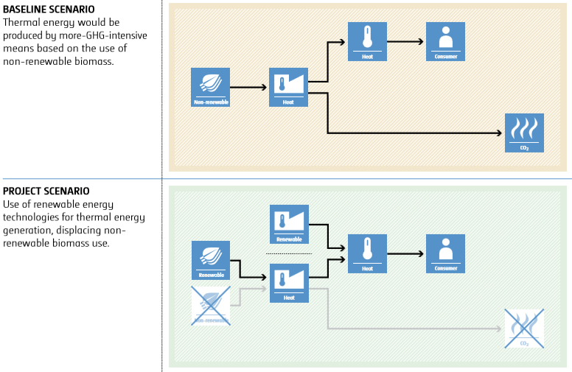

A.7. Debundling>>
This project is not a de-bundled component of a larger project activity.

SECTION B. Application of methodologies and standardized baselines

B.1. References to methodologies and standardized baselines >>

SECTORAL SCOPE – 01 Energy industries (Renewable/Non-renewable sources)

TYPE INSERT PROJECT TYPE: I - Renewable Energy Projects

CATEGORY- AMS-I.D.: Grid connected renewable electricity generation --- Version 18

B.2. Applicability of methodologies and standardized baselines >>

The project activity involves generation of grid connected electricity from the renewable biomass-based power generation project and is a Greenfield project activity. The project activity is having 10 MW installed capacity; therefore, falls in small scale project activity and eligible under small scale methodology AMS-I.D. The project status corresponding to the methodology AMS-I.D. Version 18 and applicability of methodology is discussed below:

Applicability Criterion | Project Case
This methodology comprises renewable energy generation units, such as photovoltaic, hydro, tidal/wave, wind, geothermal and renewable biomass:  - Supplying electricity to a national or a Unified Indian Grid; or  - Supplying electricity to an identified consumer facility via national/Unified Indian Grid through a contractual arrangement such as wheeling. | The project comprises of renewable biomass-based electricity generation unit which will supply electricity to a Unified Indian Grid on a contractual agreement signed with the state electricity board and thus satisfies the criteria. Hence, project activity satisfies this applicability criterion 1.a.
2. Illustration of respective situations under which each of the methodology (i.e. AMS-I.D: Grid connected renewable electricity generation”, AMS-I.F: Renewable electricity generation for captive use and mini-grid” and AMS-I.A: Electricity generation by the user) applies is included in Table 2 | According to the point 1 of the Table 2 in the methodology – “Project supplies electricity to a national/ Unified Indian Grid” is applicable under AMS I.D. As the project activity supplies the electricity to Unified Indian grid which is a Unified Indian Grid, the methodology AMS-I.D. is applicable
Applicability Criterion | Project Case
3. This methodology is applicable to project activities that:  - Install a Greenfield plant;  - Involve a capacity addition in (an) existing plant(s);  - Involve a retrofit of (an) existing plant(s);  - Involve a rehabilitation of (an) existing plant(s); or  - Involve a replacement of (an) existing plant(s). | The Project activity involves the installation of new power plant at a site where there was no renewable energy power plant operating prior to the implementation of the project activity. Thus, Project activity is a Greenfield plant and satisfies this applicability condition (a).
Hydro power plants with reservoirs that satisfy at least one of the following conditions are eligible to apply this methodology:  - The project activity is implemented in existing reservoir, with no change in the volume of the reservoir; or  - The project activity is implemented in existing reservoir, where the volume of the reservoir(s) is increased and the power density as per definitions given in the project emissions section, is greater than 4 W/m2.  - The project activity results in new reservoirs and the power density of the power plant, as per definitions given in the project emissions section, is greater than 4 W/m2 | The criterion is not applicable to the project activity as the project is a biomass project.
5. If the new unit has both renewable and non- renewable components (e.g., a wind/diesel unit), the eligibility limit of 15 MW for a small-scale CDM project activity applies only to the renewable component. If the new unit co-fires fossil fuel, the capacity of the entire unit shall not Exceed the limit of 15 MW. | The project activity involves the installation of a turbine generator with an installed capacity of 10 MW based on the renewable biomass (Rice Husk) and hence is within the 15 MW limit set by the methodology.
6. Combined heat and power (co-generation) systems are not eligible under this category | The project is not a combined heat and power plant and hence this criterion is not applicable.
7. In the case of project activities that involve the capacity addition of renewable energy generation units at an existing renewable power generation facility, the added capacity of the units added by the project should be lower than 15 MW and should be physically distinct from the existing units. | The project is a Greenfield project as there is no addition to the existing renewable power generation from the time of commissioning of the project activity and hence this criterion is not applicable.
8. In the case of retrofit or replacement, to qualify as a small-scale project, the total output of the retrofitted or replacement power plant/unit shall not exceed the limit of 15 MW. | The project is a Greenfield project as there is not any retrofit or replacement to the existing renewable power generation from the time of commissioning of the project activity and hence this criterion is not applicable.
Applicability Criterion | Project Case
9. In the case of landfill gas, waste gas, wastewater treatment and agro-industries projects, recovered methane emissions are eligible under a relevant Type III category. If the recovered methane is used for electricity generation for supply to a grid, then the baseline for the electricity component shall be in accordance with procedure prescribed under this methodology. If the recovered methane is used for heat generation or cogeneration other applicable Type-I methodologies such as “AMS I.  C.: Thermal energy production with or without electricity” shall be explored. | The project activity involves the installation of a turbine generator with an installed capacity of 14 MW based on the renewable biomass. Hence, this criterion is not applicable.
10. In case biomass is sourced from dedicated plantations, the applicability criteria in the tool “Project emissions from cultivation of biomass” shall apply. | Project activity is not based on the biomass sourced from the dedicated plantations. Hence, this criterion is not applicable

B.3. Applicability of double counting emission reductions >>
There is no double accounting of emission reductions in the project activity due to the following reasons:
- Project is uniquely identifiable based on its location coordinates,
- Project has dedicated commissioning certificate and connection point,
- Project is associated with energy meters which are dedicated to the consumption point for project developer

B.4. Project boundary, sources and greenhouse gases (GHGs)>>
As per applicable methodology AMS-I.D. Version 18, “The spatial extent of the project boundary includes the project power plant and all power plants connected physically to the electricity system that the project power plant is connected to.”
The project boundary encompasses the physical and geographical site of the renewable generation source, which is considered from the point of fuel supply to the point of power export to the grid where the project proponent has a full control, as per the guidelines mentioned in Type I.D of Annex B of the simplified modalities and procedures for small-scale CDM project activities. Hence, project boundary is considered within these terminal points.
Thus, the project boundary includes the biomass-based steam generator, steam turbine generators and the Indian grid system.

Source |  | Gas | Included | Justification/Explanation
Baseline | Grid connected electricity generation | CO₂ | Yes | CO2 emissions from electricity generation in fossil fuel fired power plants
Baseline | Grid connected electricity generation | CH₄ | No | Minor emission source
Baseline | Grid connected electricity generation | N₂O | No | Minor emission source
Baseline | Grid connected electricity generation | Other | No | No other GHG emissions were emitted from the  project
Project | Greenfield Biomass Power Project Activity | CO₂ | No | No CO₂ emissions are emitted from the project
Project | Greenfield Biomass Power Project Activity | CH₄ | No | Project activity does not emit CH₄
Project | Greenfield Biomass Power Project Activity | N₂O | No | Project activity does not emit N₂O
Project | Greenfield Biomass Power Project Activity | Other | No | No other emissions are emitted from the project

B.5. Establishment and description of baseline scenario (UCR Standard or Methodology) >>

This section provides details of emission displacement rates/coefficients/factors established by the applicable methodology selected for the project.

As per para 19 of the approved consolidated methodology AMS-I.D. Version 18, if the project activity is the installation of a new grid-connected renewable power plant/unit, the baseline scenario is the following:

“The baseline scenario is that the electricity delivered to the grid by the project activity would have otherwise been generated by the operation of grid-connected power plants and by the addition of new generation sources into the grid”.
The project activity involves a new biomass-based power plant to harness energy from combustion of biomass and generate renewable energy i.e., electricity which is used for sale to national grid through PPA arrangement. In the absence of the project activity, the equivalent amount of power would have been generated by the operation of grid-connected fossil fuel-based power plants and by the addition of new fossil fuel-based generation sources into the grid, the power produced at grid from the other conventional sources which are predominantly fossil fuel based. Hence, the baseline for the project activity is the equivalent amount of power produced at the Indian grid.
A "grid emission factor" refers to a CO₂ emission factor (tCO₂/MWh) which will be associated with each unit of electricity provided by an electricity system. The UCR recommends an emission factor of 0.9 tCO₂/MWh for the 2014 - 2020 years as a conservative estimate for Indian projects not previously verified under any GHG program. Hence, the same emission factor has been considered to calculate the emission reduction under conservative approach.

Estimated Emission Reductions: ER_{y}= BE_{y} – PE_{y} – LE_{y}

ER_{y} = Emission reductions in year y (tCO₂/y)
BE_{y} = Baseline Emissions in year y (t CO₂/y)
PE_{y} = Project emissions in year y (tCO₂/y)
L_{ey} = Leakage emissions in year y (tCO₂/y)
- Baseline Emissions

Baseline emissions include only CO₂ emissions from electricity generation in power plants that are displaced due to the project activity. The methodology assumes that all project electricity generation above baseline levels would have been generated by existing grid-connected power plants and the addition of new grid-connected power plants.
The baseline emissions are to be calculated as follows:
𝐵𝐸𝑦 = 𝐸𝐺_{BL,𝑦} × 𝐸𝐹𝑔_{𝑟𝑖𝑑,𝑦}

Where-
𝐵𝐸𝑦 | = | Baseline emissions in year y (t CO₂)
𝐸𝐺BL,𝑦 | = | Quantity of net electricity generation that is produced and fed into the grid as a  result of the implementation of this project activity in year y (MWh)
𝐸𝐹𝑔𝑟𝑖𝑑,𝑦 | = | UCR recommended emission factor of 0.9 tCO2/MWh has been considered. (Reference: General Project Eligibility Criteria and Guidance, UCR Standard,  page 4)

Project Emissions:

As per paragraph 39 of AMS-I.D, version 18, for most renewable energy project activities emission is zero.
As per applied methodology only emission associated with the fossil fuel combustion, emission from use of alternate fuel during unavailability of biomass, would be accounted for the project emission on actuals. Therefore, following project emission type has been considered for the project activity:

Coal or lignite consumption:

The project activity will be using fossil fuel like coal and lignite as alternate fuel to meet the emergency requirements of the powerhouse; hence emissions due to usage of fossil fuel will be accounted as project emissions. As per the latest guidelines of Government of India, 15% of conventional fossil fuel can be used in case of any emergency.
CO2 emissions from fossil fuel combustion in the project activity are calculated based on the quantity of fuels combusted and the CO2 emission factor of those fuels, as follows:

PEFC,y = Σ FCi,y × NCVi,y × EF CO2,i

Where:
PE_{FC,y} = Project Emission due to alternate fossil fuel consumed during monitoring period FC_{i,y} = Quantity of fuel type ‘i’ consumed in liters (lit) or tones (t)
NCV_{i,y} = Net Calorific Value of type of fuel used
EF_{CO2,i} = IPCC 2006 Emission factor for type of fuel used
i = fuel types combusted during the monitoring period

Hence, PE_{y} = PE_{FC,y}

Leakage:

As per the para 23 of the tool “Leakage in biomass small-scale project activities” version 04, under “Competing uses for the biomass” category – “The project participant shall evaluate ex-ante if there is a surplus of the biomass in the region of the project activity, which is not utilized. If it is demonstrated (e.g., using published literature, official reports, surveys etc.) at the beginning of each crediting period that the quantity of available biomass in the region (e.g., 50 km radius), is at least 25% larger than the quantity of biomass that is utilized including the project activity, then this source of leakage can be neglected otherwise this leakage shall be estimated and deducted from the emission reductions”.
In order to assess the availability of biomass in the project region, a biomass availability survey has been conducted by a credible third-party agent. Based on the biomass availability survey report it has been confirmed that there is sufficient biomass available in the region less than 50 km surrounding the site of the project activity. It confirms that there is no such leakage anticipated.
The actual ER for the project shall be calculated as per the electricity generation and export to the grid as per the requirement of the methodology. Hence, PP has already taken conservative approach to calculate the ER.

Hence, LEy = 0

The actual emission reduction achieved during the first CoU period shall be submitted as a part of first monitoring and verification. However, for the purpose of an ex-ante estimation, following calculation has been submitted:

Estimated annual baseline emission reductions (BEy)

Ex-ante calculation of emission reductions is equal to ex-ante calculation of baseline emissions as project emissions and leakage are nil.

Baseline emission factor (Combined Margin) (EF_{grid,} _{CM,} _{y} / EF _{grid, CO2,y}) = 0.9 tCO₂e/MWh

Annual gross electricity generation = 10 MW (project capacity) × 75 % (PLF) × 8760 (operating hours)
= 59,130 MWh/yr.

Combined CO₂ emission factor of the INDIAN Grid = 0.9 t CO₂/MWh

Baseline emissions from the project activity = (net electricity from the project activity* emission factor of the INDIAN grid)

Baseline emissions from the project activity = (net electricity from the project activity* emission factor of the INDIAN grid)
= (59,130* 0.9)
= 53,217tCO₂/yr

Emission Reductions from the project activity = 532,170 tCO₂/yr.

Hence, the total emission reductions after rounding off the above result, is 53,217 tons of CO₂ annually and 532,170 tons of CO₂ for the entire duration of the crediting period.

B.6. Prior History>>
The project activity has not applied to any other GHG program for generation or issuance of carbon offsets or credits for the said crediting period.

B.7. Changes to start date of crediting period >>

There is change in the start date of crediting period.
Crediting period start from 01/01/2015

B.8. Permanent changes from PCN monitoring plan, applied methodology or applied standardized baseline >>
Not Applicable

B.9. Monitoring period number and duration>>

First Monitoring Period:
08 years, 00 months
01/01/2015 to 31/12/2022 (inclusive of both dates)

First Issuance Period: 08 yrs

B.8. Monitoring plan>>

Data and Parameters available at validation (ex-ante values):

Data / Parameter | UCR recommended emission factor
Data unit | tCO₂ /MWh
Description | A "grid emission factor" refers to a CO₂ emission factor (tCO₂/MWh) which will be associated with each unit of electricity provided by an electricity system. The UCR recommends an emission factor of e 0.887 kg CO2e / kWh for the 2014 - 2020 years as a fairly conservative estimate for Indian projects not previously verified under any GHG program. Hence, the same emission factor has been considered to calculate the emission reduction under conservative approach.
Source of data | https://a23e347601d72166dcd6-16da518ed3035d35cf0439f1cdf449c9.ssl.cf2.rackcdn.com//Documents/UCRCoUStandardAug2022updatedVer6_090822220127104470.pdf
Value applied | 0.9
Measurement methods and procedures | -
Monitoring frequency | Ex-ante fixed parameter
Purpose of Data | For the calculation of Emission Factor of the grid
Additional Comment | The combined margin emission factor as per CEA database (current version 16, Year 2021) results into higher emission factor. Hence for  2021 vintage UCR default emission factor remains conservative.

Data / Parameter | NCV _{k,y}
Data unit | GJ/mass or volume unit
Description | Net calorific value of biomass type k
Source of data | Laboratory record (Archived on paper)
Value applied | - (an average value is given for representation)
Measurement methods and procedures | IPCC Default Value is considered.  OR  Monitoring equipment – Bomb Calorimeter Water equivalent = H 🞫 M 🞫 (CV_{t} + CV_{w}) / T Where:
H = Calorific value of Benzoic acid in cal/gm M = Mass of sample in gm
CVt = calorific value of thread (per cm = 2.1 cal)
CVw = calorific value of ignition wire (per cm = 2.331 cal) T = final rise in temperature
Purpose of Data | Calculation of baseline emission
Comments | The data will be archived electronically, and the archived data will be kept for 2 years beyond the Crediting Period

Data / Parameter | EF CO2,i
Data unit | tCO₂e/TJ
Description | CO2 emission factor of fossil fuel type i
Source of data | IPCC default value
Value applied | 74.8
Measurement methods and procedures | The project proponent chooses default value option i.e., IPCC default values at the upper limit of the uncertainty at a 95% confidence interval as provided in Table 1.2 of Chapter 1 of Vol. 2 (Energy) of the 2006 IPCC Guidelines on National GHG Inventories and is fixed Ex-ante. This is in accordance to the “Tool to calculate project or leakage CO2 emissions from fossil fuel combustion”, latest version applied.
Purpose of Data | Calculation of project emission
Comments | This parameter is fixed ex-ante for the entire crediting period.

Data and Parameters to be monitored (ex-post monitoring values):

Note: For the purpose of baseline ER accounting only one ex-post parameter is relevant, i.e. Net Electricity supplied to the Grid by the project activity (EG _{BL,y}). However, in line with the registered CDM monitoring plan, few other monitoring parameters are also included. Hence, at the time of baseline emission reduction calculation only the EG _{BL,y} will be used; whereas other parameters may be considered only for reporting purposes.

Main Monitoring Parameter for calculation:

Data / Parameter: | E_{Gen}
Data unit: | MWH/month
Description: | Net electricity generated at generating point by project activity
Source of data: | Monthly Meter Reading Performa by CSEB
Measurement  procedures (if any): | Monitoring equipment – MAIN Energy Meter  Accuracy class - 0.2s  Calibration frequency- once in five years  Monitoring equipment – CHECK Energy Meter  Accuracy class - 0.2s  Calibration frequency- once in five years  Measured readings of the energy meter installed at the plant switchyard outgoing feeder grid interconnection point. This will be recorded every month by Monthly Meter Reading by CSEB. This record will be archived and stored.
Monitoring frequency: | Continuously/monthly
Value Applied : | 59,130 MWh/Yrs
QA/QC procedures: | Calibration of the Main meters will be carried out once in five (5) years as per National Standards (as per the provision of CEA, India) and faulty meters will be duly replaced immediately as per the provision of power purchase agreement.  Cross Checking:  The meter reading is cross checked with the sales receipts of electricity. The meters installed are owned by the state utility and the meter is tri- vector type of meter which can measure both export and import
Any comment: | All the data will be archived till a period of two years from the end of the crediting period.

https://a23e347601d72166dcd6-16da518ed3035d35cf0439f1cdf449c9.ssl.cf2.rackcdn.com//Documents/UCRCoUStandardAug2022updatedVer6_090822220127104470.pdf

