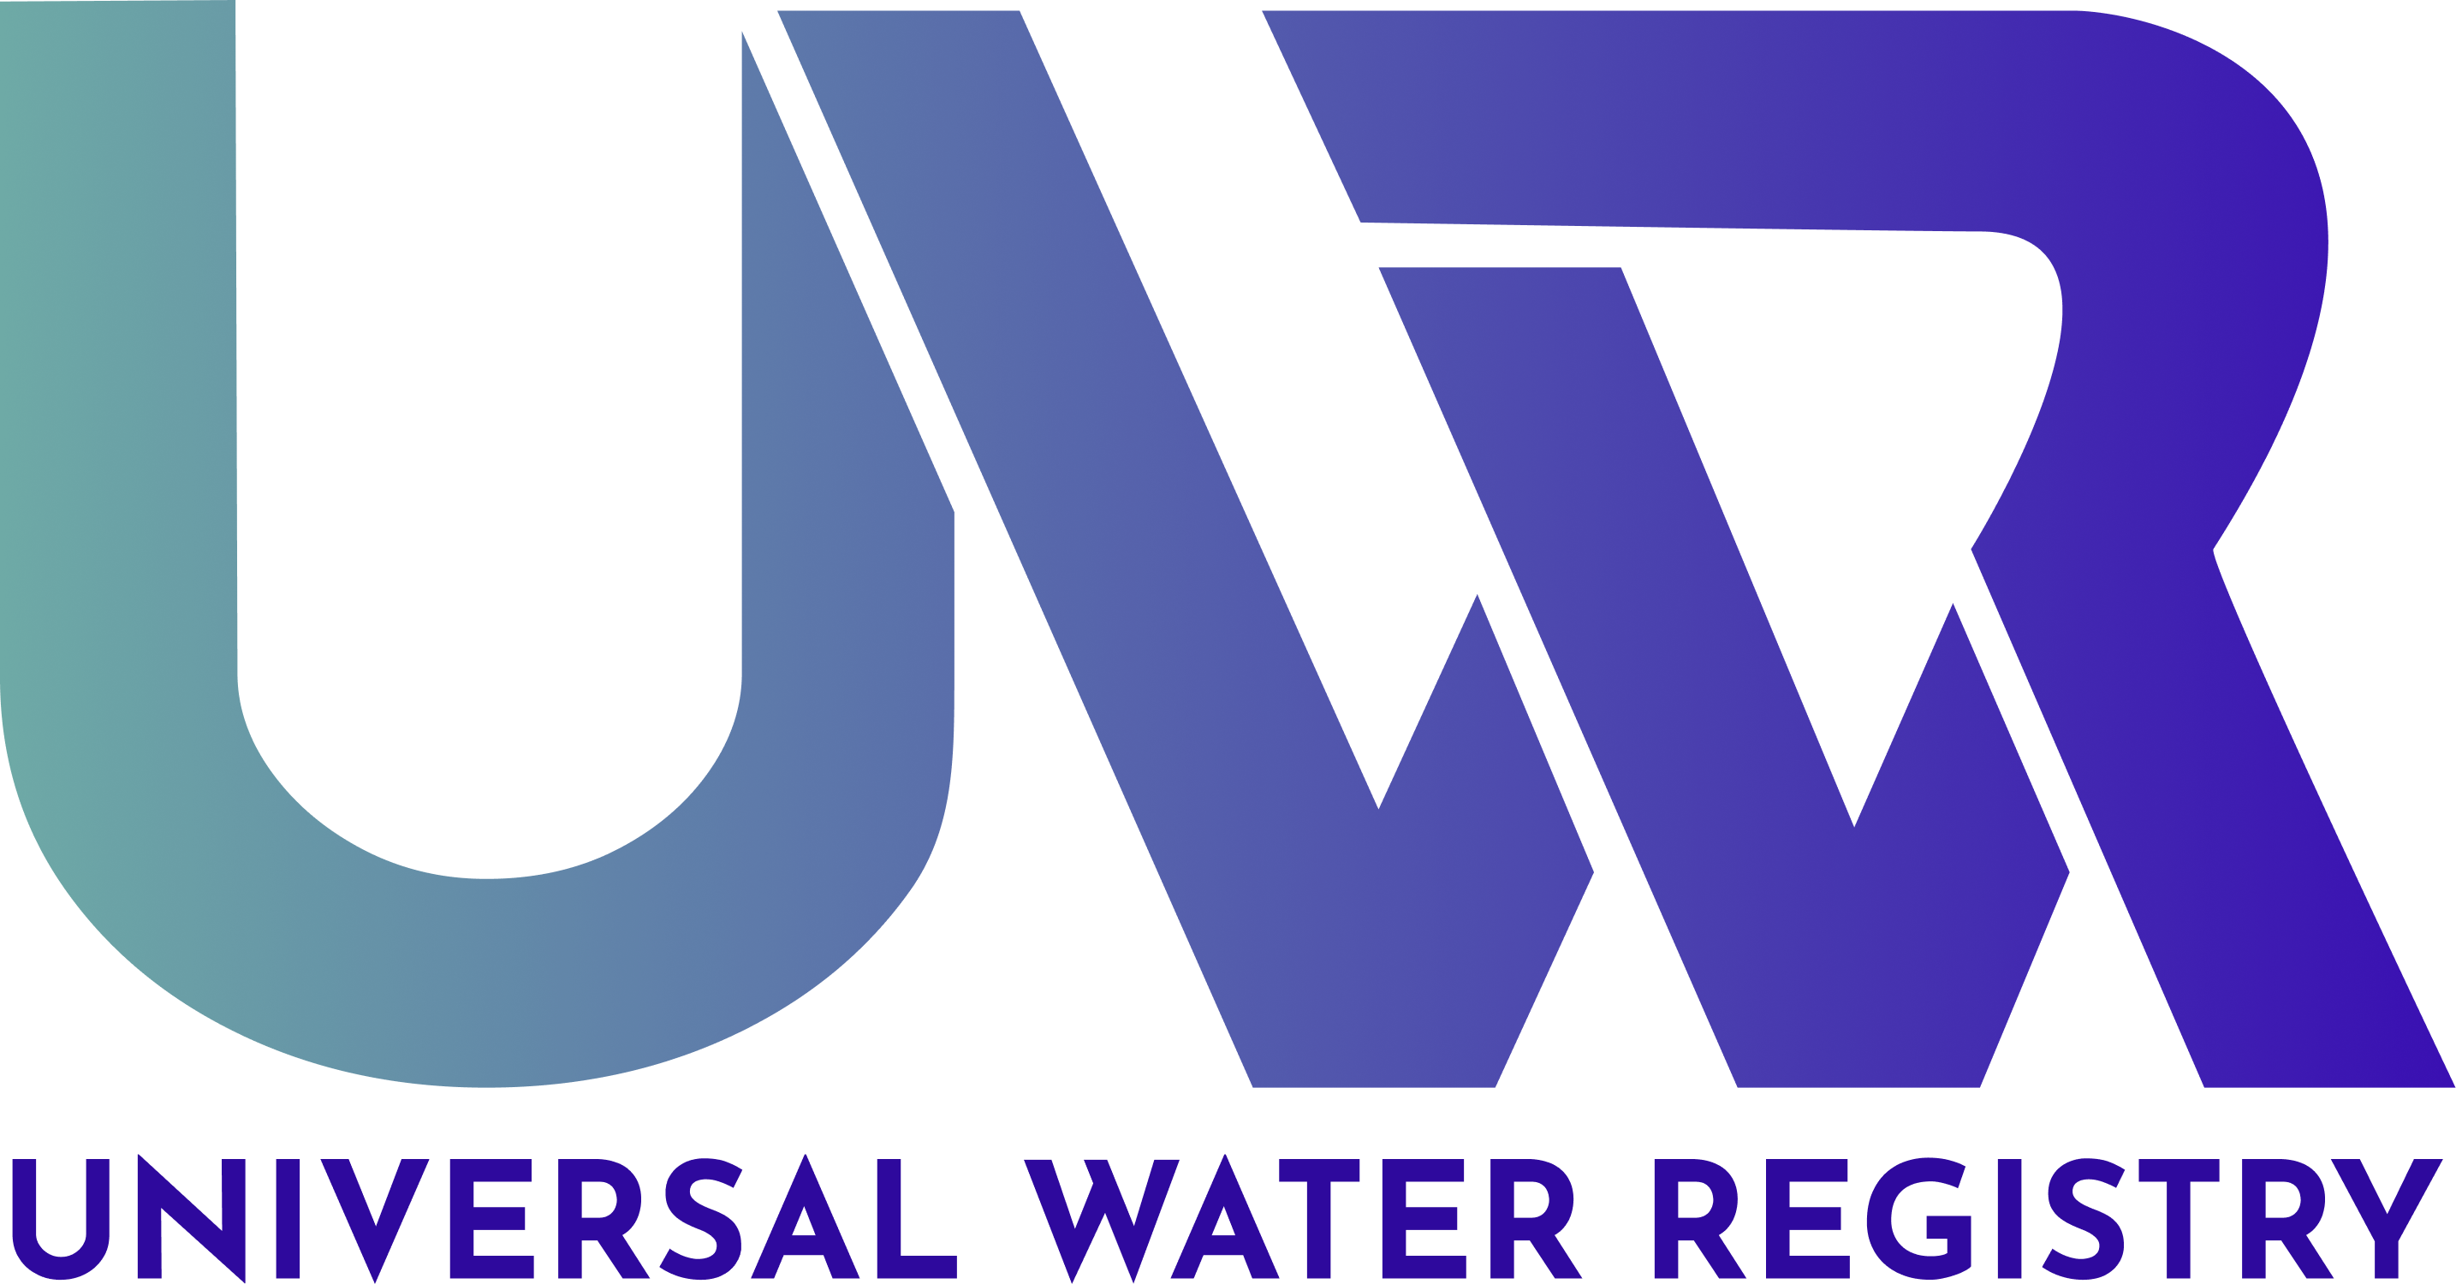

UWR Rainwater Offset Unit Verification Statement
UWR RoU Verification Statement

Ver 2.0
Date 21/10/2023

Project Name & UWR ID :______________________

UWR RoU Scope:_____________________

Monitoring Period: DD/MM/YYYY-DD/MM/YYYY

Crediting Period: YYYY-YYYY

UNDP Human Development Indicator:______
National Water Security Index: _____
UWR Verification Statement
Each RoU Verification Report submitted to UWR must include the following RoU Verification Statement as provided below.

Verification Statement

This statement issued by_____________________________________ (UWR Verifier) to the UWR Program and Registry is to confirm that _____________________________________ (UWR Verifier) has evaluated the RoU assertion by _____________________________________ (Project Proponent/Seller) covering the period from (DD/MM/YYYY) ___________to ___________ (DD/MM/YYYY) according to the protocols outlined in the UWR Rainwater Offset Standard/Program and in conformity with the UWR Rou Verification Standard. _____________________________________ (UWR RoU Verifier) confirms all verification activities have been completed and concludes without any qualification or limiting conditions that the RoU assertion by _____________________________________ (Project Proponent/Seller) is without material discrepancy and that the verification activities provided the reasonable level of assurance prescribed by UWR RoU program rules that the RoU assertion is materially correct. The RoU assertion provided by _____________________________________ (Project Proponent/Owner/Seller) has resulted in the recharge, conservation, or savings enhancement of:

Vintage: ___2014_____________ 1000 Litres or m3: ___________________
Beginning (DD/MM/YYYY): ___________________ End (DD/MM/YYYY): ___________________

Vintage: ___2015___________ 1000 Litres or m3: ___________________
Beginning (DD/MM/YYYY): ___________________ End (DD/MM/YYYY): ___________________

Vintage: ___2016_____________ 1000 Litres or m3: ___________________
Beginning (DD/MM/YYYY): ___________________ End (DD/MM/YYYY): ___________________

Vintage: ___2017_____________ 1000 Litres or m3: ___________________
Beginning (DD/MM/YYYY): ___________________ End (DD/MM/YYYY): ___________________

Vintage: __ 2018_____________ 1000 Litres or m3: ___________________
Beginning (DD/MM/YYYY): ___________________ End (DD/MM/YYYY): ___________________

Vintage: __ 2019_____________ 1000 Litres or m3: ___________________
Beginning (DD/MM/YYYY): ___________________ End (DD/MM/YYYY): ___________________

Vintage: ___2020_____________ 1000 Litres or m3: ___________________
Beginning (DD/MM/YYYY): ___________________ End (DD/MM/YYYY): ___________________

Vintage: ___2021_____________ 1000 Litres or m3: ___________________
Beginning (DD/MM/YYYY): ___________________ End (DD/MM/YYYY): ___________________

Vintage: ___2022_____________ 1000 Litres or m3: ___________________
Beginning (DD/MM/YYYY): ___________________ End (DD/MM/YYYY): ___________________
Attestation:
______________________________________ ________________________________________
Lead Verifier (Print Name) Senior Internal Reviewer (Print Name)

_____________________________________ ________________________________________
Lead Verifier (Signature) Senior Internal Reviewer (Signature)

______________________________________ ________________________________________
Date (DD/MM/YYY) Date (DD/MM/YYYY)
Project Proponent Authorization:

I, _____________________________________ (UWR member/Owner/Aggregator), authorize the above-named verifier to submit this Verification Statement to the UWR.
_____________________________________ ______________________________________
Member/Owner/Aggregator (Print Name) Member/Owner/Aggregator (Signature)

_____________________________________ Date (DD/MM/YYYY)

APPENDIX A

VERIFIERS STATEMENT OF POTENTIAL OR ACTUAL CONFLICTS OF INTEREST

Requirement to Submit a Statement of Conflicts of Interest: Before a Verifier begins any verification work for a Project, the Verifier must submit to a statement of any potential or actual conflicts of interest that may result from undertaking such verification work.

The statement shall include proposed steps that may be taken to avoid, mitigate or neutralize the potential or actual conflict of interest.

The statement shall be signed by the Project Owner. The statement shall also refer to any appearance of conflict of interest that may arise even if this does not lead, in the opinion of the parties signing the statement, to a substantive conflict of interest. UWR Staff shall evaluate statements of potential or actual conflicts of interest on a case-by-case basis and make recommendations on an appropriate course of action.

The Verifier shall make full disclosure in writing to UWR immediately of any change in circumstances that may lead to the emergence of any conflict of interest in the provision of verification services. This disclosure shall include a description of actions taken or that will be taken to avoid, neutralize, or mitigate the actual or potential conflict of interest.

Circumstances that Present an Actual or Potential Conflict of Interest

Performance of the following services for a Project Owner or Seller may result in a conflict of interest for a Verifier wishing to provide verification services to that Project Owner or Seller:
1. Designing, developing, implementing, or maintaining a water footprint inventory.
2. Designing or developing water or wastewater sustainability information systems.
3. Developing water sustainability factors or other water-related engineering analysis.
4. Designing water sustainability projects which explicitly identify water credits or RoUs or water related green credits as a benefit.
5. Preparing or producing water-related manuals, handbooks, or procedures specifically for the RoU project activity.
6. Appraisal services of water stressed liabilities or assets.
7. Brokering in, advising on, or assisting in any way in water -related markets.
8. Management over health, environment and safety functions.
9. Legal and expert services unrelated to RoU verification for UWR purposes.
10. Verifier and Owner share board members or senior management.
11. If there is a financial, functional or structural link (e.g. common ownership, contractual arrangement, or informal contract) between the parties, whether directly or through affiliated organizations (e.g. holding companies, parent companies etc).

Other factors that may constitute a conflict of interest include, without limitation: subsidiaries, formal partners, affiliates, etc.

Verifier/s must not be involved in any commercial, financial or other processes with the owner or aggregator of the project activity that might influence their judgment and render it not impartial or not objective.

Process for Evaluating Statement of Conflicts of Interest:

The statement must be sent to the UWR RoU Program or concerned department of the UWR via email displayed on the website. This statement is to be filled out by the Verifier.
Verifier Providing Verification Services (Personnnel names)
Verifier Organization Name
Verifier Organization Website
Verifier Mailing Address
Project Owner Name
Project Owner Company
Project Type
Project Name
Project Location
Has your organization provided certification or verification services for the above project owner in connection with any other water trading, water credits issuance or other water green credit systems during the previous three years? If yes, list the years and nature of the verification services provided.
Has your organization provided any non-verification services to the project owner during the previous three years? Are there any plans or contracts for your organization to continue to provide such services on an ongoing basis or in the future? If yes, what was the nature of the work performed? When was it performed? What was the scale of the work performed.
Identify all potential sources of conflict of interest that may arise if your organization performs verification services for the above-named project owner. If the potential conflict of interest may arise indirectly through an affiliated organization, please describe the nature of that link.
Please provide a list of names of the staff that are providing verification services to the above-named Project Owner. For these staff, are there any instances of personal or professional relationships or financial interests that may represent a potential conflict of interest? If yes, please detail. •
Are there particular reasons why this work should be considered sensitive, highly visible or subject to special scrutiny (e.g., press coverage, special interest, prior controversy, etc.)?

We hereby warrant the truthfulness of the answers to all questions on this form and the attached statement and documentation and to any other questions that may be asked by UWR or its designated representatives. We agree to maintain the accuracy and completeness of the information contained in this form and the attached statement and documentation. We undertake to immediately notify UWR in writing about any material change in any information contained in this form and the attached statement and documentation. We authorize UWR or its designated representatives to obtain information from sources that they deem appropriate in order to adequately evaluate and process this form and the attached statement and documentation and to ensure the integrity and effective operation of the UWR in the future. We understand that failure to provide full and accurate information may result in the delay or rendering invalid of any decision made in response to the information contained in this form and the attached statement and documentation.

Signed and accepted by duly authorized representatives of:

_______________________ _________________________________
RoU Verifier Name: Project Owner Name/ Company

_________________________ ________________________________
Title Title

_____________________ ______________________________
Signature of RoU Verifier Project Owner/Aggregator Signature

:________________________________ ________________________________
Date Date

