
UWR Rainwater Offset Unit Standard
(UWR RoU Standard)
Concept & Design: Universal Water Registry
www.uwaterregistry.io

Project Concept Note & Monitoring Report
(PCNMR)
Project Name :______________________
UWR RoU Scope:_____________________
Monitoring Period: DD/MM/YYYY-DD/MM/YYYY
Crediting Period: YYYY-YYYY
UNDP Human Development Indicator:______
A.1 Location of Project Activity
State
District
Block Basin/Sub Basin/Watershed | Please refer to  http://cgwb.gov.in/watershed/basinsindia.html
Lat. & Longitude
Area Extent
No. of Villages/Towns

*Provide maps where applicable
A.2. Project owner information, key roles and responsibilities
It is important that the roles and responsibilities are clearly documented here within the management plan including clear lines of accountability and reporting Project owner shall attest to the following and that owner:
(a) owns the water user rights for the area within the project's boundary,
(b) holds an uncontested legal land title for the project area within the project's boundary,
(c) holds all necessary permits to implement the project or has applied for the same, AND
(d) provides cost details of project implementation .

A.2.1 Project RoU Scope
PROJECT NAME
UWR Scope:
Date PCNMR Prepared

A.3. Land use and Drainage Pattern
- Cultivable & Non-cultivable Area Forest
- Urban
- Other
Example:
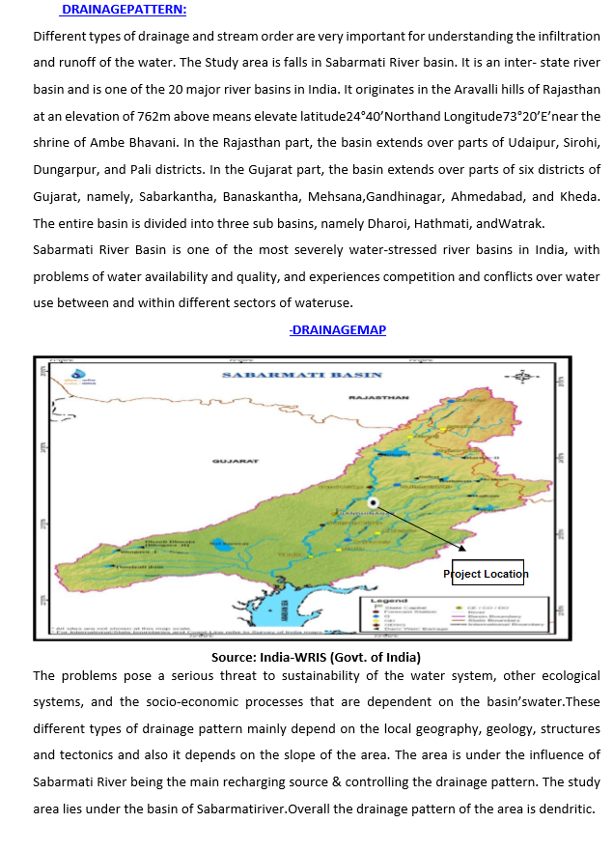
A.4. Climate
- Type of Climate
- Humid
- Sub-Humid
- Arid
- Semi-arid

A.5. Rainfall
    - (a) Average annual :______________mm
    - (b) No. of Rainy days:________________
    - (c) Temperature:___________
Example:
The project activity area experiences a hot to semi‐arid climate. The summer season continues for about four months between March and June and the temperature rises as higher as 45⁰C in the month of May and during winter it falls up to 10ºC during December. The Ahmedabad dist. as a whole faces acute shortage of water due to frequent failure of monsoon creating drought like situation.
The area is highly favorable for setting the monsoon in the fourth week of June and ends in the month of September. The overall annual average rainfall of the area is 750 to755mm. During this period, all the streams & channels are flopped with water. The short‐term average rainfall of the Ahmedabad City is 754mm IMD (2000‐2020) with about only 35 complete rainy days. The annual rainfall of the study area is tabulated in the Table no 1. During last 21 years period (2000‐2020) maximum rainfall recorded was 1186 mm in the year 2010 & minimum was 382 mm in the year 2015.
The rainfall data also shows that during last 21 years only 10 years had received above normal annual rainfall and remaining period of the year received sub normal Rain. Rainfall plays an important role in the availability of groundwater inthis region and it is a major source for groundwater recharge.
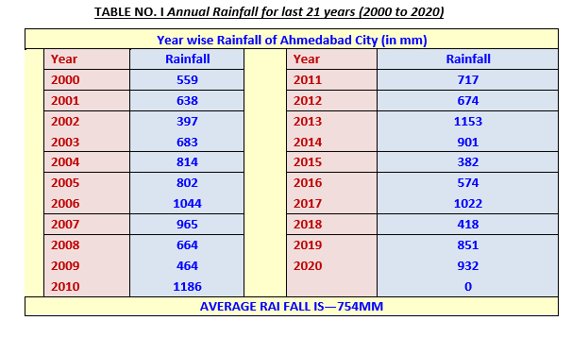

A.6. Ground Water
- Description of aquifer: (Refer Water Data Guide under Documents on www.ucarbonregistry.io or https://indiawris.gov.in/wris/#/Aquifer )
- Unconfined & confined aquifers
(a) Potable
(b) Brackish
(c) Saline
(ii) Any special quality problem, (Seawater intrusion, pollution, high fluoride etc.).
Additional Resource:
http://jalshakti-dowr.gov.in/sites/default/files/MasterPlanForArtificialRechargeToGroundWater2020.pdf

A.7. Alternate methods
Using base data on topography, rainfall, hydrogeology, aquifer situation land source water availability (if available), identify the methods which may be suitable and why the current method in the project activity was selected by the project proponent
A.8. Design Specifications
For individual structure at different locations, please describe the design specifications of the implemented project activity.Please include flow charts and diagrams where needed.
Please describe parameters involved in estimation of quantity that has been diverted for artificial recharge, the time for which the unutilized/source water was available, the quality of source water and the pretreatment required (if any) and describe the conveyance system being used to bring the water to the recharge site.
A.9. Implementation Benefits to Water Security
Describe the number of such types of artificial recharge structures needed to achieve or have been installed to meet the quantitative targets for the region or facility.
Example 1:
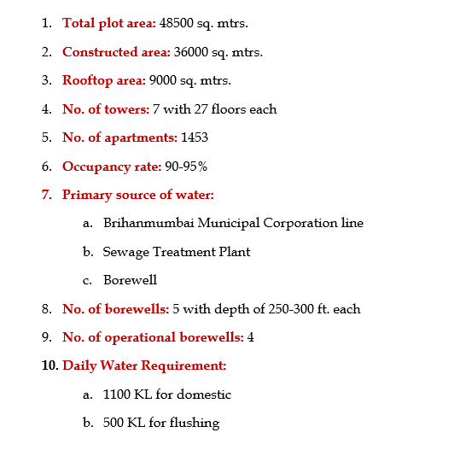
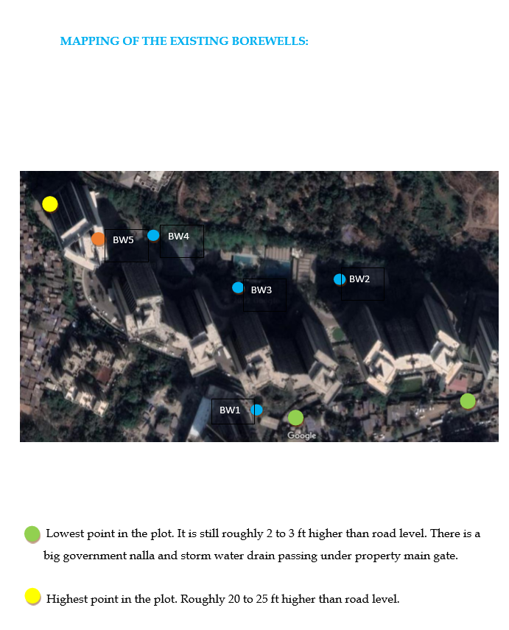

Example 2:
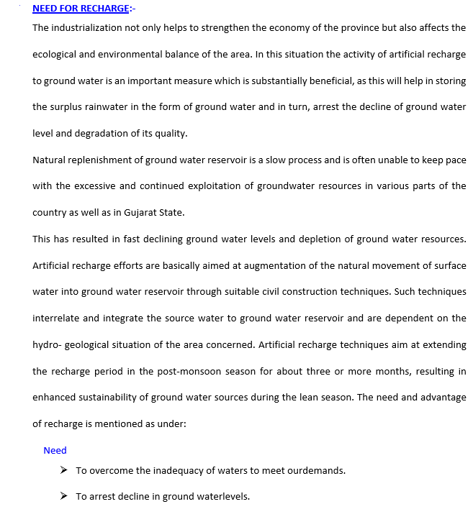

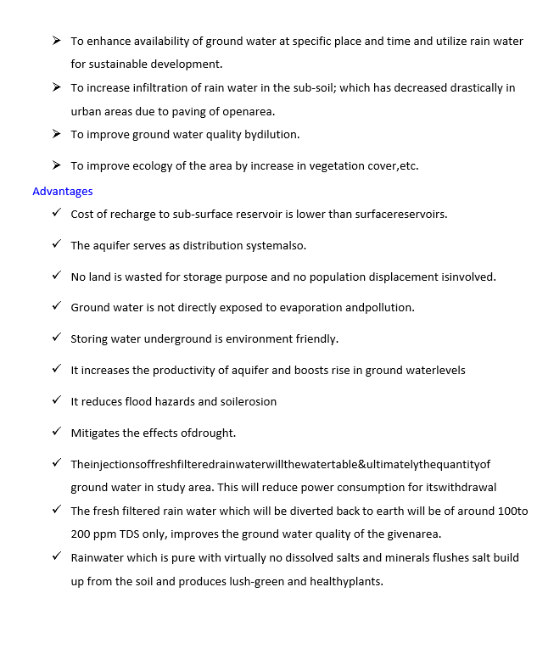

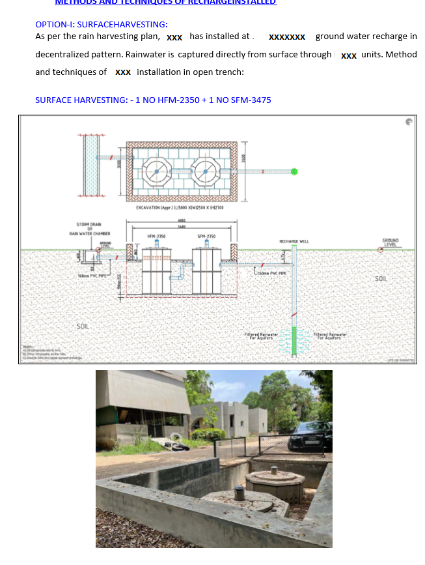

A9.1 Objectives vs Outcomes
Describe in detail the objective of the project activity and the outcome post commencement of the activity. Provide diagrams and pictures where applicable for justification.
Example
Objective: The major objective was to make the area water sufficient and poverty-free while increasing the water-harvesting capacity of the village. Ensuring participatory planning and educating women on watershed management.
Outcome: Farm ponds were made deeper than usual to conserve more rainwater and to ensure its availability for a longer duration. Changes in cropping pattern led to increased incomes. Higher yield and improved production of paddy. Emergence of fishery as a new livelihood activity, due to availability of sufficient water in farm ponds. Better yield in the lowlands due to water storage and seepage. Increased confidence of community members on farm ponds for irrigation. Vegetable farming using trellis proved profitable and many farmers now plan to grow more vegetables using water stored in the farm ponds.
A9.2 Interventions by Project Owner / Proponent / Seller
Describe in detail the interventions carried out by the project activity to achieve the desired outcome.
Example
Awareness and capacity-building efforts were undertaken to identify the problem faced by the community and the willingness to resolve it. ƒ A hydrogeological mapping of the area was done to identify the recharge area of the critical springs more accurately. ƒ A water budget for the village was designed based on the estimated amount available for use and demanded by the community. ƒ For demand management, protocols were established in the village to ensure the sustained impact of the interventions. Some of the protocols included recharge area protection, social fencing, crop-water analysis based farming, crop diversification, etc. and the outcome post commencement of the activity.
A.10. Feasibility Evaluation
Briefly evaluate the economic feasibility of the Project activity undertaken or prior third party findings and result and recommendations of audit reports as applicable.

A.11. Ecological Aspects & Sustainable Development Goals (SDGs):
Please provide a description of the potential environmental/ecological problems being addressed by the project activity in terms of
- a) Inundation of habitated land
- b) Creation of water logging and vector disease prevention mitigation
- c) Deterioration of quality of groundwater
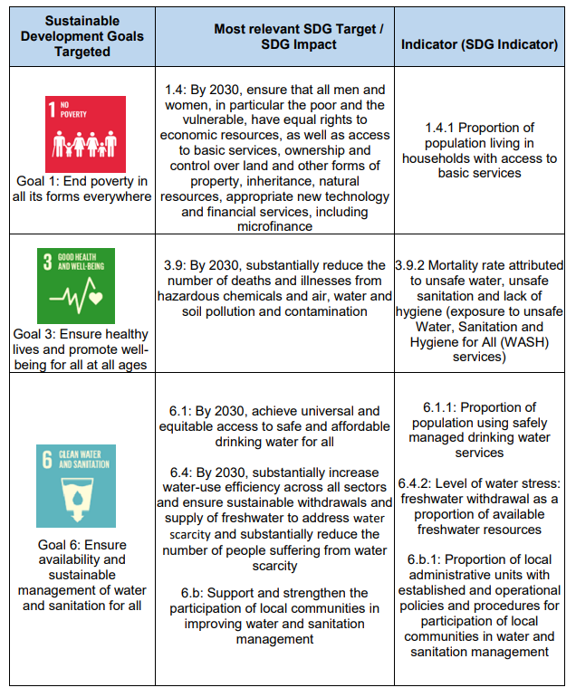
Example of SDGs Impact and Indicators

A.12. Recharge Aspects :
Please document efforts taken to ensure that the Quality of Surplus Recharge water is clean, free from contamination and has compatibility with quality of native ground water in aquifers.
A.12.1 Solving for Recharge
Ultimately, the volume of groundwater recharge benefit to the subbasin is the most critical aspect for such MAR activities. Groundwater recharge is quantified as the deep percolation of surface water applied during project implementation. Using a field-scale water budget, deep percolation can be calculated as the difference between all other inflows and outflows, per the equation below, with each other inflow and outflow being quantified:
Recharge = Rainfall + Surface Inflow – Evapotranspiration – Surface Outflow – Change in Storage
Evapotranspiration & Other Data: https://datameet-pune.github.io/open-water-data/docs/open-water-data-paper.pdf (or available under Documents Section- Water Data Guide)
Root Zone = The root zone is comprised of the upper portion of the soil where water extraction by roots occurs, above the depth at which water infiltrates to the groundwater system. The depth to the bottom of the root zone varies by crop, but typically extends up to seven feet.
Surface Inflow= Surface inflows can be either directly measured or calculated from measured values. In fields directly served by metered lift pumps or metered gates, the volume of surface inflows to the field can be directly measured or calculated from totalized measurements. Typical accuracies of pipe flow measurements range from 1-12 percent. In fields that are indirectly supplied with surface water, surface inflows may need to be calculated from upstream and downstream flow measurements, or through theoretical or empirical equations relating available data to field surface inflows. For example, fields served from canals measured using weirs, or fields served from canals that deliver water to multiple locations downstream of a measurement device may require site-specific calculations to quantify surface inflows to a specific field. Low-cost in-field measurements can also be made by setting up flashboards at the measurement location and correlating the “runup” of an unsubmerged weir overflow on a flat weir stick to the flow rate using standardized equations. Typical accuracies of “runup” or indirect flow measurements may exceed 10 percent, depending on site conditions and the accuracy of measurement data.
To monitor surface inflows, project owners may record flow data, maintain irrigation logs, and maintain logs of any other parameters required to calculate field deliveries, depending on the unique conditions of their field. Project owners may also consider using mobile flow monitoring equipment to measure or verify surface inflows.
Surface Outflows: To monitor surface outflows, users may record flow data or water level data and maintain logs of any other parameters required to calculate outflows, depending on the unique conditions of their project activity. Pressure transducers and dataloggers may be used to automatically monitor water levels, or users may install wooden stakes to manually monitor water depths.
Change in Storage = The change in surface storage, or average ponded water depth, can be calculated from measured and observed changes in water surface levels at points throughout the project field. Over the annual project implementation period, the total change in surface storage is typically zero, provided that the surface of a field is dry and free of ponded water at the start and end of the project.
While the uncertainty of each inflow and outflow will vary based on field conditions and measurement devices, typical uncertainties associated with each water budget component are summarized in the table below. The uncertainty of deep percolation (i.e., recharge) can then be calculated from these other uncertainties, for example following the process described by Clemmens and Burt (1997). Users can use the following table to eliminate uncertainty from their estimates.
Water Budget Component | Typical Estimated Uncertainty (%) | Description
Surface Inflow | 1-12% | Typical range of accuracy from meters to minimum delivery accuracy requirements of delivery and diversion measurement devices.
Precipitation | 2-20% | Typical range of accuracy from field-level rain gauges to extrapolation of local weather station data
Surface Outflow | 1-20% | Typical range of accuracy from meters to estimated outflow relationships
Evapotranspiration | 20.00% | Clemmens and Burt, 1997; typical accuracy based on free water surface evaporation coefficient.
Change in Storage | 15-25% | Estimated accuracy of change in storage calculation based on field scale water budget calibration to observed water levels.
Deep Percolation | 5-30% | Typical range of calculated accuracy from field-scale water budget results (fields ranging from 56 to 125 acres)

Other factors of uncertainty to consider when quantifying recharge are:
• Deep percolation does not immediately recharge the groundwater system. There is a time lag between when deep percolation occurs through the root zone and when that water reaches the saturated groundwater system.
• Subsurface inflows and outflows can occur through the groundwater system. While deep percolation may supply water to the groundwater system, that water may migrate away from the field along groundwater gradients.
Groundwater recharge can also be monitored and verified through groundwater level measurements at groundwater wells adjacent or near to the project activity. For instance, groundwater level measurements collected before, during, and after implementation can potentially help verify that net recharge is occurring; especially in well-positioned wells with continuous monitoring.
A.13. Quantification Tools
The following tools are recommended to be used to estimate the quantity of RoUs in the absence of tamperproof flow meters or systems that accurately quantify the volume in litres or m3 of water being harvested or conserved by the project activity.
Water Harvesting Potential
Water harvesting potential of any catchment area is to be calculated under this methodology for each given year that the RoU is being claimed. The total amount of water that is received from rainfall over an area is called the rainwater legacy of that area. The amount that can be effectively harvested is called the water harvesting potential.
The formula for calculation for harvesting potential or volume of water received or runoff produced or harvesting capacity is given as:-
Harvesting potential or Volume of water utilized (liters) = | Area of Catchment/Roof/Collection Zone (m²) X Amount of rainfall (mm) X Runoff coefficient

*All calculations of RoUs for should be rounded down against the lower of the two values (if any) between RoUs calculated and RoU values as per IS 15797:2008 for the given year being quantified (2014 onwards).

Estimated Net Runoff from an Impervious Catchment Surface Adjusted by its Runoff Coefficient (metric units) catchment area (m² ) X rainfall (mm) X runoff coefficient = net runoff (liters)
EXAMPLE: In an area receiving 304 millimeters of rain a year, you have a rooftop catchment surface that is 15 meters long and 9 meters wide, and you want to know how much rainfall can realistically be collected off that roof in an average year.
You want a conservative estimate of annual net runoff, so you use a runoff coefficient of 80% or 0.80. (Since the roof is a rectangular area, use the following calculation for catchment area as in Equation— catchment area (m² ) = length (m) x width (m)—which is figured into the calculation below.
((length (m) X width (m)) X rainfall (mm) X 0.80 = net runoff (liters) (15 m x 9 m) x 304 mm x 0.80 = net runoff (liters) 135 m² x 304 mm x 0.80 = 32,832 liters
32,832 liters = net runoff collected (without RoU Standard uncertainty factors accounted for).
A realistic estimate of the volume of water that could be collected off this 15 meter by 9 meter roof in a year of average rainfall is 32,832 liters or 32 RoUs (since 1 RoU = 1000 liters)

Runoff coefficient
Runoff coefficient for any catchment is the ratio of the volume of water that runs off a surface to the volume of rainfall that falls on the surface. Runoff coefficient accounts for losses due to spillage, leakage, infiltration, catchment surface wetting and evaporation, which will all contribute to reducing the amount of runoff. Runoff coefficient varies from 0.5 to 1.0. Rooftop rain water harvesting systems shall use the runoff coefficient equal to 1 as the rooftop area is totally impervious. Eco-climatic conditions (i.e. Rainfall quantity & Rainfall pattern) and the catchment characteristics are considered to be most important factors affecting rainwater harvesting potential .
Type of Area | Recommended Runoff Coefficient (K)
Residential | 0.3 to 0.5
Forest | 0.5 to 0.2
Commercial & Industrial | 0.9
Parks and Farms | 0.05- 0.3
Asphalt or Concrete Paving | 0.85
Road surface | 0.8-0.9

Runoff Coefficient of Different Surfaces
Different Surfaces | Runoff Coefficient (K)
Roof conventional (Flat) | 0.7 to 0.8
Roof inclined (Sloping) | 0.85 to 0.95
Concrete/Kota Paving | 0.6 to 0.7
Gravel | 0.5 to 0.7
Brick Paving | 0.7

Annual Rainwater harvesting Potential
Annual rainwater harvesting potential is given by V = K × I× A
Where, V=Volume of water that can be harvested annually in liters.
K = Runoff coefficient
I = Annual rainfall in (mm)
A = Catchment area in (m²)

Rainfall intensity in the catchment area
The rainfall intensity of the area is to be found out from the local IDF -curves (intensity-duration frequency curve), if IDF-curve is not available, rainfall intensity default of 100 mm/hr shall be considered (this value is for tropical countries, with catchment areas smaller than 150 ha).
Analysis of the catchment area
The gradient of the catchment area, terrain configuration in the catchment area can be found out from the State Maps and the Runoff factors for the different terrain are given as below. Coefficient of Runoff Values for Different Terrains
Terrain type | ‘C’ Coefficient of Runoff (Flat terrain)
Clayey soil | 0.8 2
Parking area | 0.75
Roads and other concrete works | 0.85
Green belts | 0.1

Rainfall infiltration method
In areas where ground water level monitoring is not adequate in space and time, rainfall infiltration may be adopted. The norms for rainfall infiltration contributing to ground water recharge are evolved, based on the studies undertaken in various water balance projects in India. The norms for recharge from rainfall under various hydrogeological situations are recommended in the following table

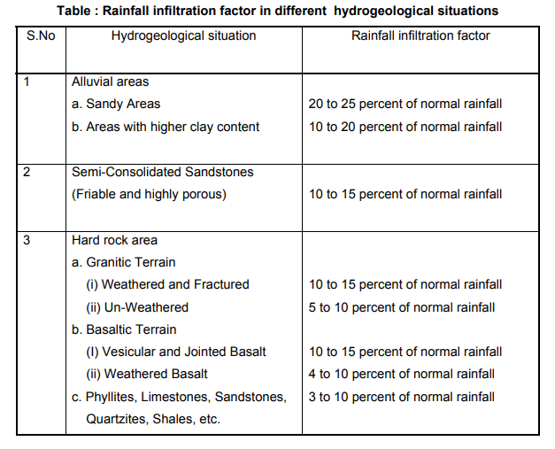
Additional Guidance On Groundwater Recharge estimates and guidelines:
UWR recommends following the estimates and guidelines outlined here http://cgwb.gov.in/documents/Manual%20on%20Artificial%20Recharge%20of%20Ground%20Water.pdf
Interim Report on Project wise Impact Assessment of Completed Demonstrative Artificial Recharge Projects of XI Plan (http://cgwb.gov.in/Ar-reports.html)
Additional Guidance For Rooftop Rainwater Harvesting Systems:
In order to be conservative in the estimation of the quantity of rainwater harvested, RWH users of this methodology are advised to also refer to IS 15797:2008 Indian Standard Roof Top Rain Water Harvesting guidelines on estimation.
Table 1 can also be used for conservative estimates for Rooftop Rainwater Harvesting Systems:

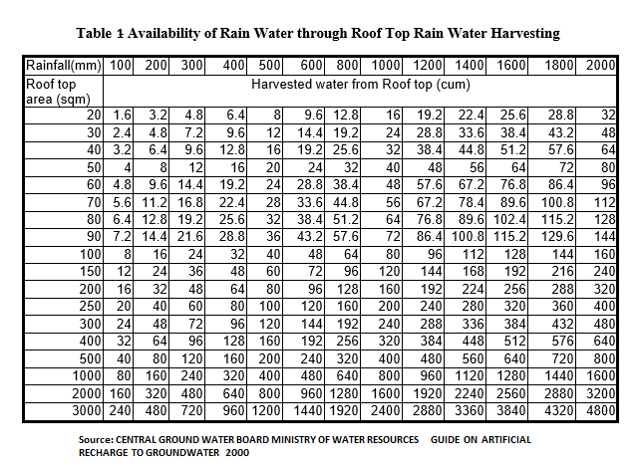
Quantification
Year (January 01, 2014 onwards) | RoUs (1 RoU = 1000 litres)/yr *
DD/MM/YYYY | Number
Conservative Approach: The UWR RoU Verifier is recommended to apply a 10-50% uncertaintity factor related to degree of uncertainity to the final quantity of RoUs calculated for vintage years 2014-2021. However, a more conservative approach to uncertaintity may be selected by the RoU Verifier as per its discretion.
*All calculations of RoUs should be rounded down against the lower of the two values (if any) between RoUs calculated and RoU values as per IS 15797:2008 for the given year (2014 onwards).
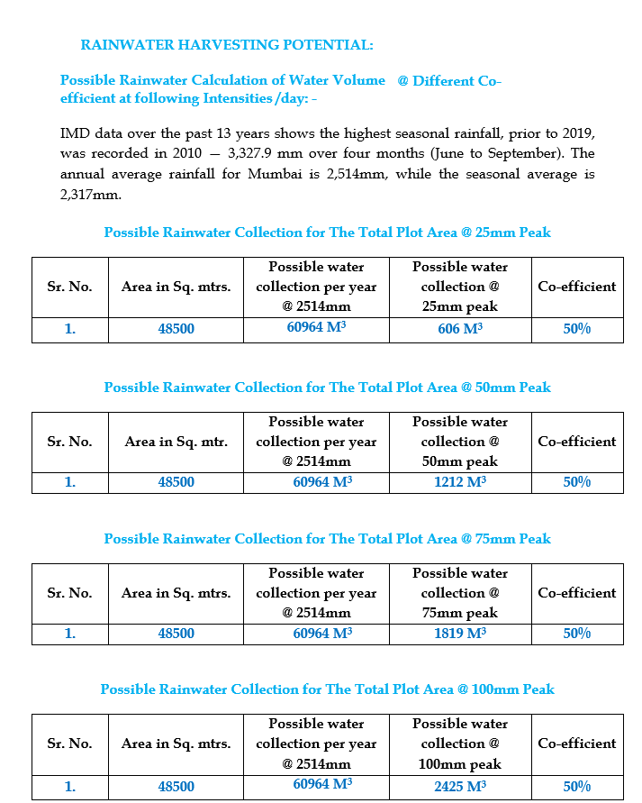
Example:

A.14. UWR Rainwater Offset Do No Net Harm Principles
Describe how the project activity accomplishes the following:
- Increase the sustainable water yield in areas where over development has depleted the aquifer
- Collect unutilized water or rainwater from going into storm drains or sewers
- Conserve and store excess water for future use
- Enhance local women’s participation and professional development

A.15. Scaling Projects-Lessons Learned-Restarting Projects
Please describe how the project can be scaled further and take into account existing integrated practices, as well as areas of duplication that might contribute to better water and urban management.
Example:
Efforts to introduce wastewater recycling for direct potable water supply have failed in many cities because of the perception that reclaiming drinking water from municipal effluent is generally unacceptable to the public. However, the experience in XYZ showed that with persistent, well-designed, and targeted communication to the public, this perception can be changed. The people of the village XYZ generally take pride in the fact that they are one of only a few villages in the world where direct potable water reuse is practiced. Furthermore, there is evidence to show that this is indeed a safe practice: in 5 years of recycling water for drinking water supply, the village has not had a single outbreak of waterborne disease linked to this practice.
Example:
Stormwater harvesting for domestic use had to be abandoned at some sites as it turned out not to be the most cost-efficient option when the full range of costs and benefits were taken into account. However, the revenue from the sale of RoUs under the UWR Program has now meant that such stormwater harvesting abandoned earlier can be restarted.
It's proposed that in 2023, the PP will undertake 32 abandoned stormwater projects and the water will be supplied to gardens and sports clubs, totaling 1.4 million m3 of water supply.

